Human computer interaction design

**Phase #4– prototyping for SUrveypro, an online survey system**

Table of Contents

High fidelity prototype improvements based on low fidelity prototype feedback 2

Environmental requirements 2

**Hardware Requirements** 2

**Software Requirements** 3

Installation Instructions for SurveyPro 3

**Extraction of ZIP file** 3

Operation Instructions for SurveyPro 4

Development notes for SurveyPro 5

Bibliography 7

# **High fidelity prototype improvements based on low fidelity prototype feedback**

By combining the most promising features from our low-fidelity prototype, we have carefully developed a high-fidelity prototype for SurveyPro. To ensure that users can easily understand and use the program, we have carefully built this platform to combine tradition with aesthetics. Our main goal has been to promote "learnability," which enables users to quickly become familiar with the features of the application. As a result, we carefully incorporated assistance symbols to support users when they run into problems. These improvements are a direct result of the invaluable user feedback we received during the testing process, and we are certain that they will improve usability and accessibility while appealing to a broad range of users.

We have incorporated a critical feature that enables our users to interact with our customer support team in light of the varied demographics and technological proficiency among our target users. This fully dedicated team is committed to responding to user feedbacks and issues in order to maximize the effectiveness and overall success of the application. We are sure that this strategy will improve user experience and provide crucial assistance for those who might experience difficulties accessing the program. Additionally, we've carefully considered a number of factors to guarantee users get the best possible experience.

In conclusion, a user-centric methodology has served as the foundation for the development of SurveyPro. We created a prototype that is user-friendly and accessible by frequently incorporating user feedback and addressing the complex needs of our diversified target users. We believe that the final product will be an overwhelming success, meeting and beyond the expectations of our valued users. The final product is further strengthened by our relentless focus on detail and dedication to providing an amazing user experience. Based on the invaluable feedback obtained from our target users, we carefully incorporated the best features from the low-fidelity prototype into our high-fidelity prototype.

# **Environmental requirements**

## **Hardware Requirements**

* You will need to have access to a computer or server in order to host and run the SurveyPro website. You must be sure your hardware can support the anticipated load.

## **Software Requirements**

* To view and use the survey platform, users of SurveyPro must have a web browser which is compatible to the device such as Google Chrome, Mozilla Firefox, Microsoft Edge, and Safari. Mostly preferred web browser to run the website is Safari.
* To upload and manage the PHP, MySQL, HTML, CSS, JQuery files on your web server, you will need an FTP (File Transfer Protocol) client. FileZilla, WinSCP, and Cyberduck are a few well-known FTP clients. Mostly preferred is XAMPP. The safe transfer of files between your local computer and the web server is made possible by this software.
* To upload and run the website, you will need to download XAMPP to host the website locally on the server.

The successful implementation and accessibility of the SurveyPro online survey system depends on several environmental and hardware requirements. We have to ensure the best performance and security for our users, and make sure we routinely maintain and update both the hardware and software components.

# **Installation Instructions for SurveyPro**

## **Extraction of ZIP file**

**Option1**

* Download the Zip Archive file
* Do a right-click on the ZIP file.
* Go to the context menu and choose "Extract All."
* To specify the extraction location and start the process of extraction, follow the on-screen prompts.

**Option 2**

* Download the Zipped Archive file.
* Launch the zip file application of your choice, such as 7-Zip or WinZip.
* From within the utility, open the ZIP file.
* Select the extraction location.
* To extract the contents, use the utility's "Extract" or equivalent button.

# **Operation Instructions for SurveyPro**

After unzipping the files, please follow these easy steps to start using SurveyPro:

* Navigate to the folder where you extracted the files after extracting them in accordance with the preceding steps. This is the folder named "SurveyPro" by default.
* Copy or Move the SurveyPro Folder to the “htdocs” directory in the XAMPP(upon downloading) folder in your device.
* Then locally host the website on the server using the following path, <http://localhost/SurveyPro/admin/index.php> and <http://localhost/SurveyPro/index.php>

respectively on separate tabs on your window. First link is to open the admin (survey creator) account to manage the survey. And second link is for the user who can be a student, business professional or a researcher.

* Start with Login using the admin credentials in the first link provided. Admin Username is [mihir@admin.com](mailto:mihir@admin.com) and Password is “mihir123” . You can also use alternate Username and Password which are [admin@admin.com](mailto:admin@admin.com) and “admin1234” respectively.

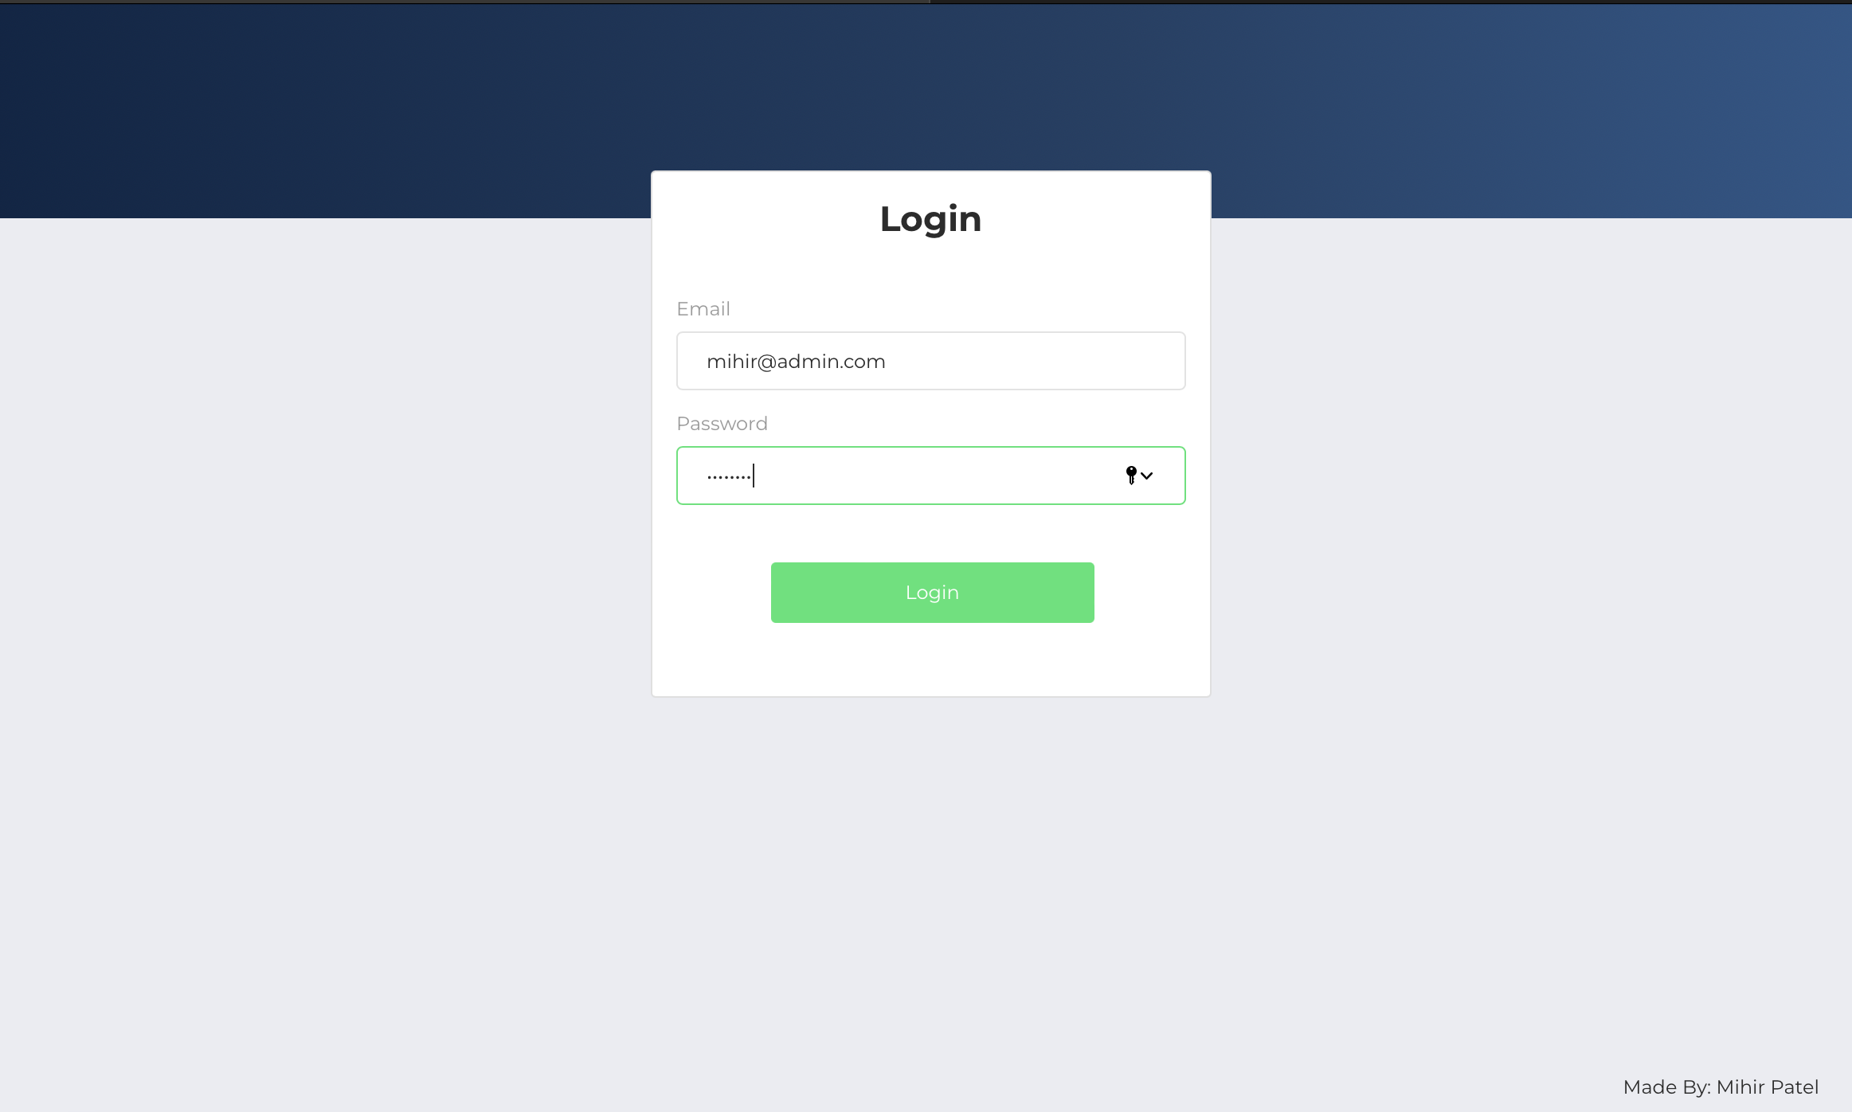

* By default, you will be on the dashboard page. So, you can move to the “Add Survey Group/Respondent” Page to create survey group and if needed then you can also add survey respondent one at a time.

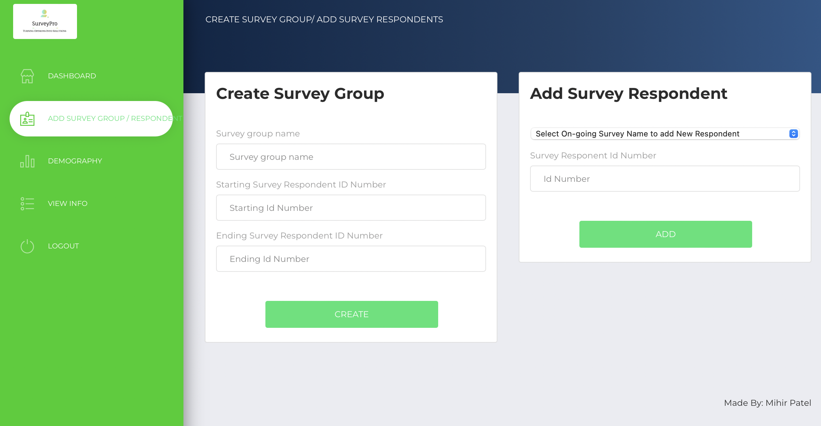

* Then on dashboard page, you can create a survey filling in some details. Make sure to keep the survey status to running so that you or other survey respondent can give the survey. If the survey is kept in pending status and the user logs in to his account then he will see nothing. So, it is necessary to keep the status to running.

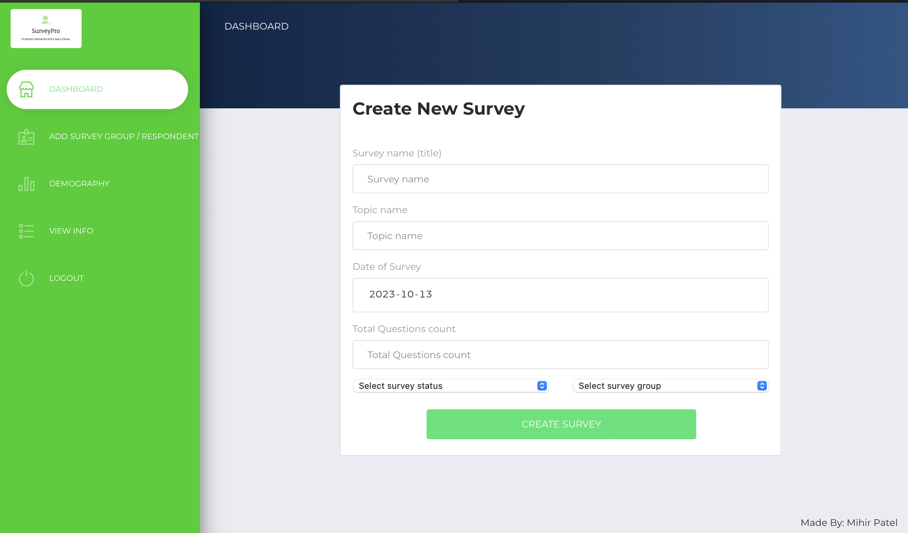

* On creating you will be able to see the name of your survey on the dashboard page.

You can update, delete, add new questions, add guest user and also make the status of the survey as completed on completion of the survey.

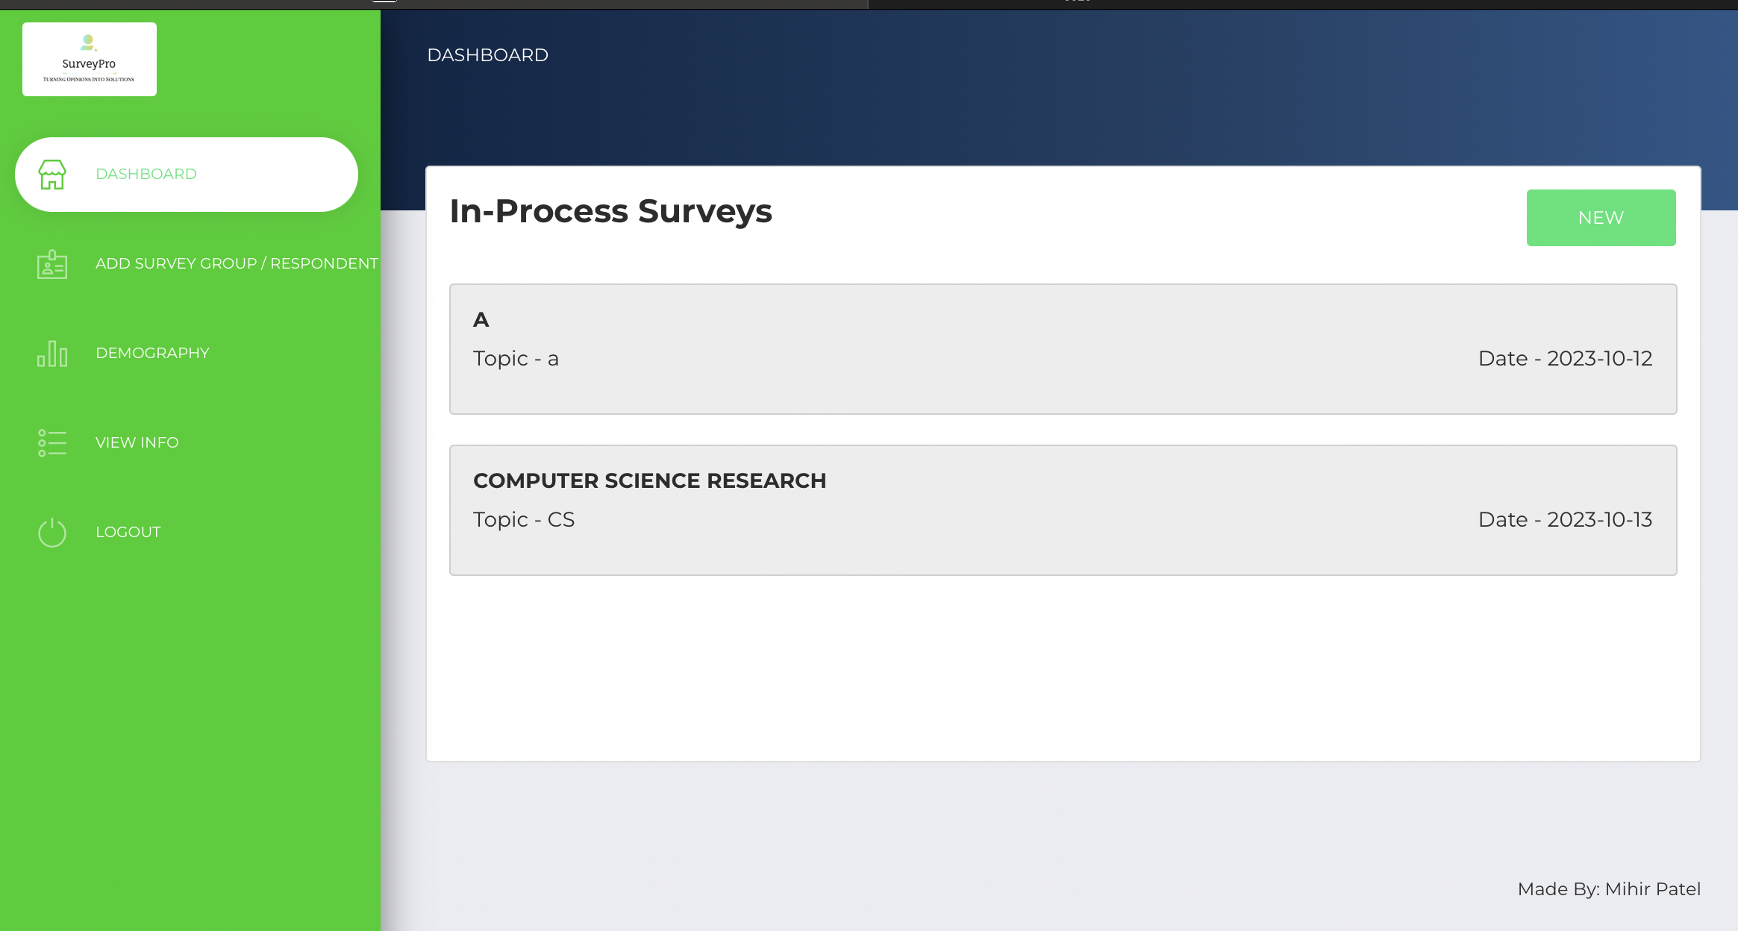

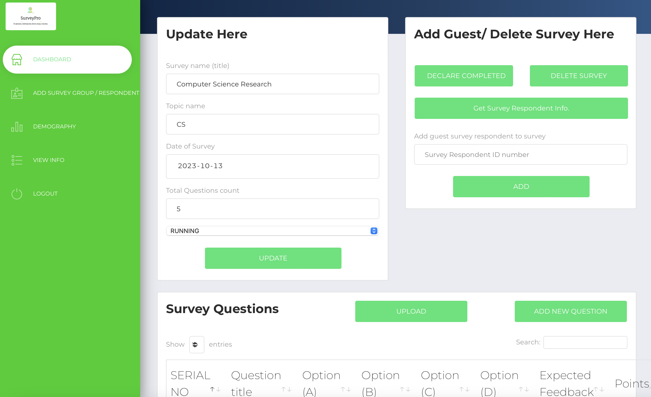

* On adding question to the survey. You can click on the button “Get Survey Respondent Info” to see their Respondent ID and Password that can be shared with individual users to give surveys.

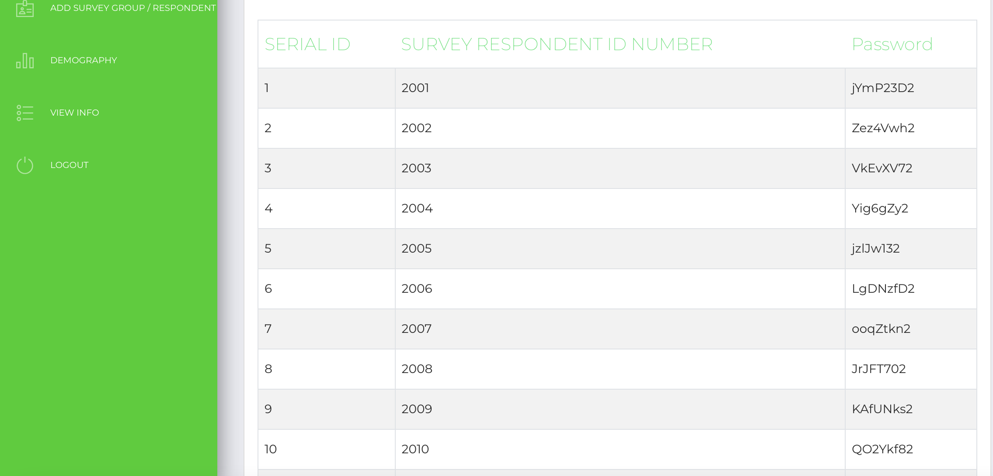

* For giving the surveys, the user can use the second link provided, enter his/her respondent id and password to give the survey.

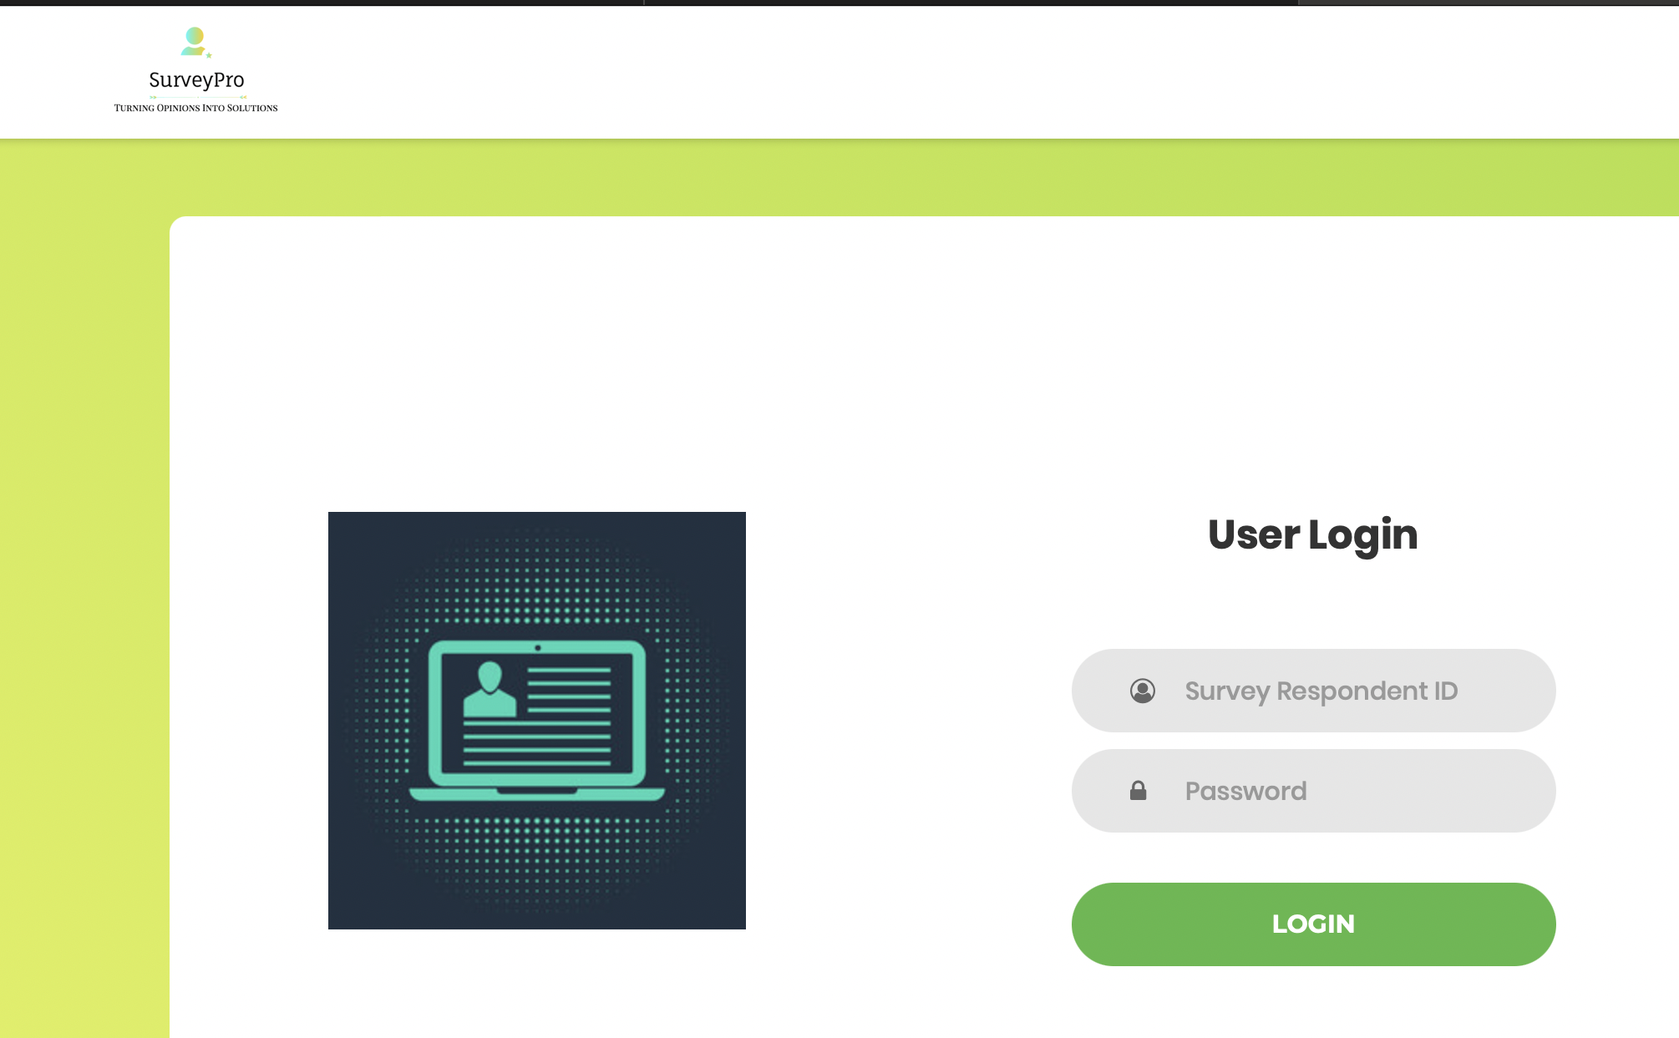

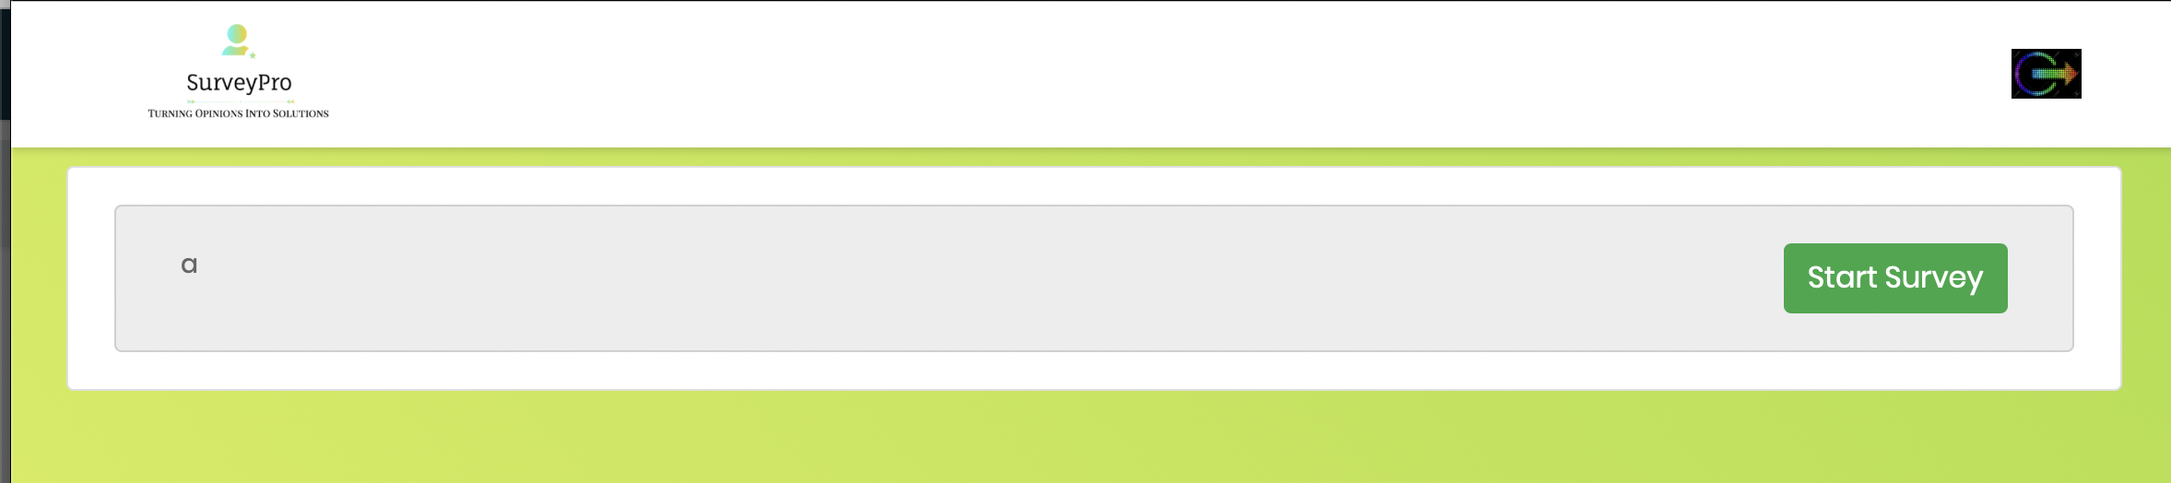

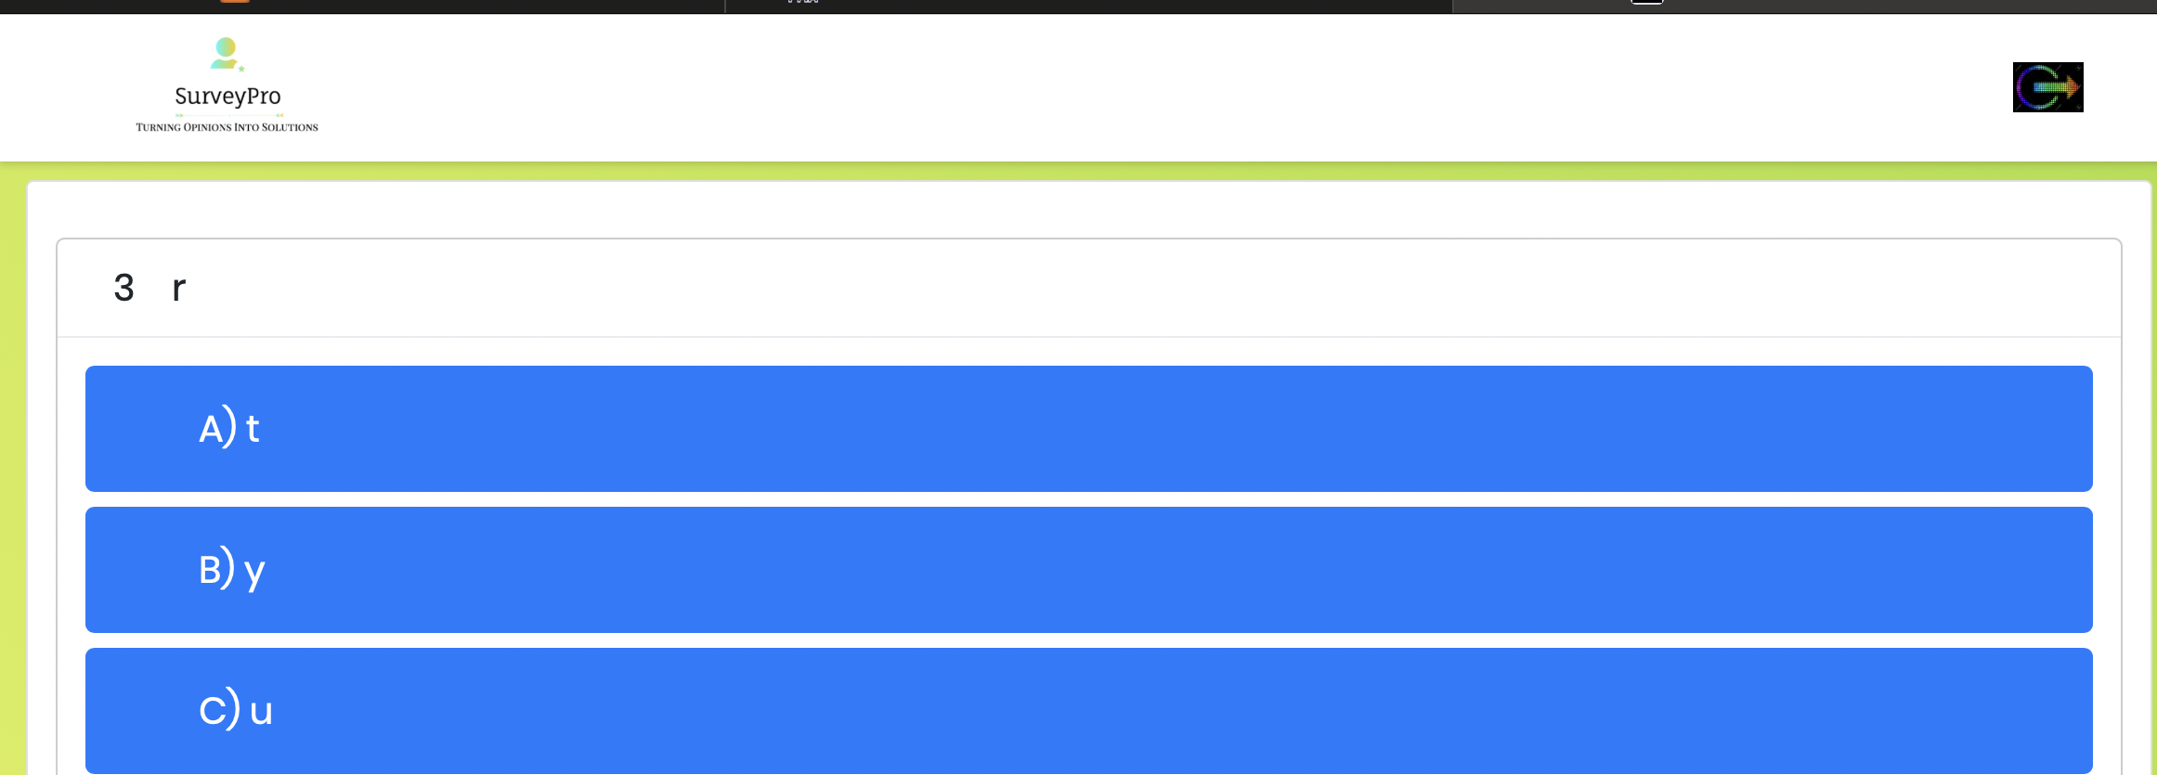

* After every respondent has given survey, the survey creator or the admin can declare the status of the survey as completed by clicking on the button “Declare Completed” on the admin dashboard page on clicking their survey which are currently in-process.

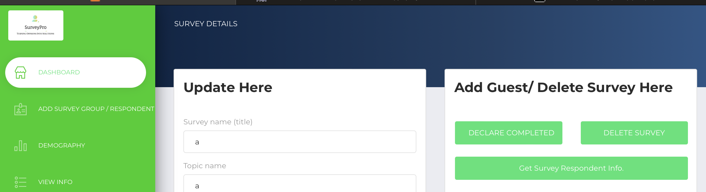

* The user can see how many users have provided surveys with the expected feedback. This page is under development currently for visualization of the results or feedbacks from different survey respondents.

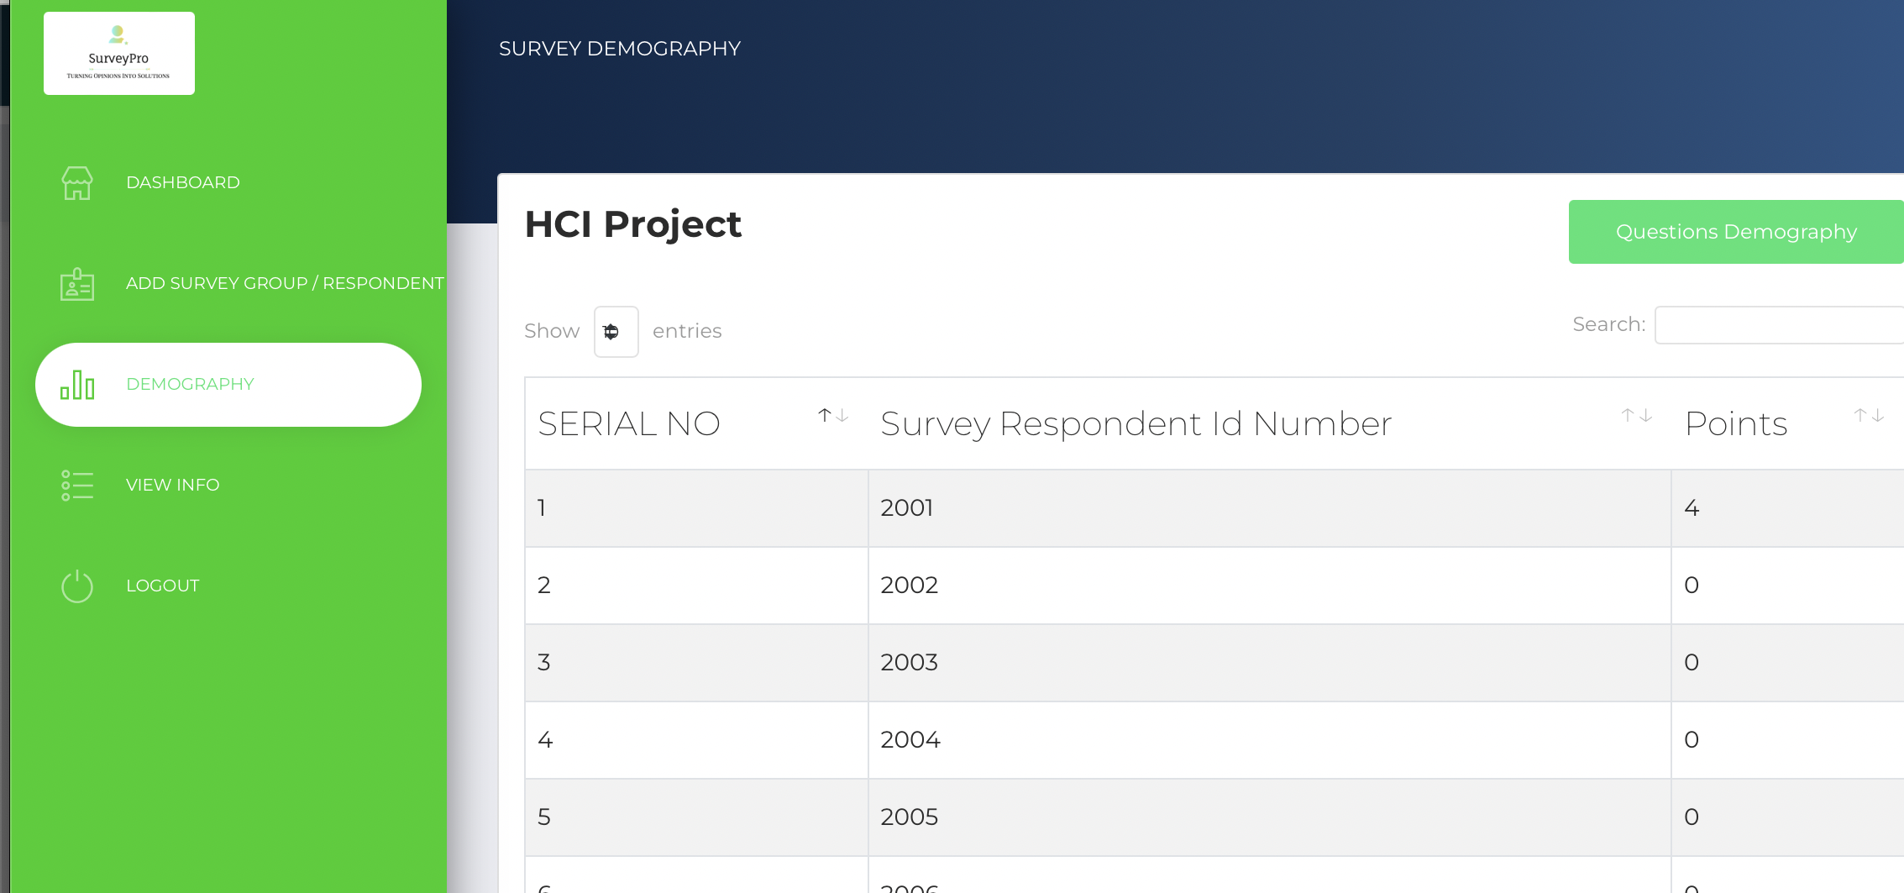

* On Completion, to exit, you can click on logout.

# **Development notes for SurveyPro**

In order to develop SurveyPro, an online survey system, we took a user-friendly and engaging design approach. The following are its primary features and development considerations:

* We have developed a safe and effective admin registration process in order to provide a strong administrative environment within SurveyPro. In contrast to conventional user registrations, the chief SurveyPro administrator grants and monitors admin access. Admin registration involves giving the assigned administrators or survey creators with special login information, such as a username and password. To guarantee that only authorized individuals can access the admin operations, these credentials are normally provided over secure channels or in person.
* SurveyPro's user login functionality is essential for serving administrators and respondents alike. By entering their given respondent ID and password, respondents can gain access to the system. This method removes the requirement for respondents to register separately and streamlines the login process. It's crucial to emphasize that the administrator provides the respondent ID and password throughout the setup process. By ensuring that the appropriate people have access to the system for managing and participating in surveys, this technique upholds security and user environment control.
* The core of SurveyPro is the survey dashboard, which gives administrators total control over survey administration. Administrators have an abundance of options on the dashboard, including the ability to create new surveys, update old ones, and remove surveys that are out of date. To improve the surveys, administrators can also add, modify, and remove survey questions as needed. The management of survey groups and individual respondents is also made possible via the dashboard. With the help of this tool, survey managers can customize the survey experience for different respondents and organize surveys based on predetermined criteria. The survey dashboard serves as the administrative hub for all survey-related operations, enabling administrators to effectively plan, direct, and enhance the survey-taking procedure.
* All pages on SurveyPro have a consistent, easy-to-use navigation bar that makes it simple to access the platform's most important components. Users may navigate between important places with ease due to the navigation bar, which serves as a trustworthy guide. Two such areas are the dashboard and the user login page. This navigation bar makes things easier for users, making it more efficient and intuitive, whether administrators are in charge of surveys or respondents are getting ready to take surveys. It guarantees that users may easily access the features they require, irrespective of their role.
* The presence of a home logo symbol facilitates easy navigation back to the dashboard or homepage. This icon, which is located in the upper-left corner of the navigation bar, is a useful shortcut. From any page, users can go back to the dashboard or the website's home page. Especially for administrators who frequently go between the dashboard and the homepage for survey administration, this straightforward and effective function improves the user experience.

SurveyPro's user-centric design makes sure that both administrators and respondents can easily access the features and resources required to make survey administration and participation simple and effective. This method provides administrators with strong control, streamlines the login process for respondents, and preserves uniform platform navigation. It's made to make sure that every encounter with SurveyPro is beneficial and easy to use.

Our objective is to build SurveyPro as an established platform for online surveys that is user-centric, informative, and trustworthy while fostering strong user relationships.

# **Bibliography**

Bostock, M. (n.d.). D3.js - Data-Driven Documents. <https://d3js.org/>

Free visual Sitemap generator from URL & XML Sitemap creator. (n.d.). Octopus.do, Visual Sitemap Tool, Website Planner, Architecture. <https://octopus.do/sitemap/resource/generator>

(n.d.). Google Forms: Sign-in. <https://forms.google.com/>

(n.d.). Matplotlib — Visualization with Python. <https://matplotlib.org/>

(n.d.). pandas. <https://pandas.pydata.org/>

Preece, J., Sharp, H., & Rogers, Y. (2015). Interaction design: Beyond human-computer interaction. John Wiley & Sons.

(2022, July 27). Qualtrics. <https://www.qualtrics.com/>

(n.d.). Stack Overflow. <https://stackoverflow.com/>

(n.d.). SurveyMonkey. <https://www.surveymonkey.com/>

(n.d.). Typeform. <https://www.typeform.com/>

(n.d.). YouTube. <https://www.youtube.com/@technobroad691>

(n.d.). YouTube. <https://www.youtube.com/watch?v=xdtzPHZXrVcs>

(n.d.). YouTube. <https://www.youtube.com/watch?v=VVkfSNwJOwc>

Now UI dashboard by creative tim. (n.d.). Premium Bootstrap Themes and Templates: Download @ Creative Tim. <https://www.creative-tim.com/product/now-ui-dashboard>